1. Lab Specific Section: I. Requirements Elicitation & Modeling
This section documents the deliverables for Lab 1, focusing on the software requirements and the visual modeling of the system context.
1.1 Software Requirements Specifications (SRS)
Based on the ShopSphere scenario, the software requirements are defined as follows:
1.1.1 System Actors The system interacts with the following primary entities:
- Web Customer: End-users who browse products, manage carts, and make purchases.
- Administrator: Internal users who manage product catalogs and process orders.
- Payment Gateway: An external system responsible for processing financial transactions securely.
1.1.2 Functional Requirements
- For Web Customer:
  - Register and Login.
  - Search and Browse Product Catalog.
  - Manage Shopping Cart (Add/Remove items).
  - Make Purchase (Checkout).
  - Manage Personal Profile.
- For Administrator:
  - Product Management (Create, Read, Update, Delete products).
  - Order Processing (View and update order status).
1.1.3 Architecturally Significant Requirements (ASRs) The following ASRs have been identified as critical drivers that will influence the system architecture:

ASR ID | Quality Attribute | Description | Architectural Impact
ASR-1 | Security | The system must protect sensitive user data (PII) and financial information. Only authenticated users can access personal profiles or admin functions. | Authentication & Authorization: Requires dedicated security modules (e.g., JWT, HTTPS) at service entry points.
ASR-2 | Performance | The system must support a high volume of concurrent users browsing the catalog without performance degradation. | Separation of Concerns: The Product Service should be decoupled to allow independent scaling or caching strategies.
ASR-3 | Availability | The user's shopping cart state must be persisted across sessions. Data should not be lost if the browser is closed. | State Management: Requires a robust persistence mechanism for session data, separating UI logic from data storage.

1.2 Modeling Artifact: UML Use Case Diagram
The following diagram illustrates the system boundaries, actors, and major use cases.
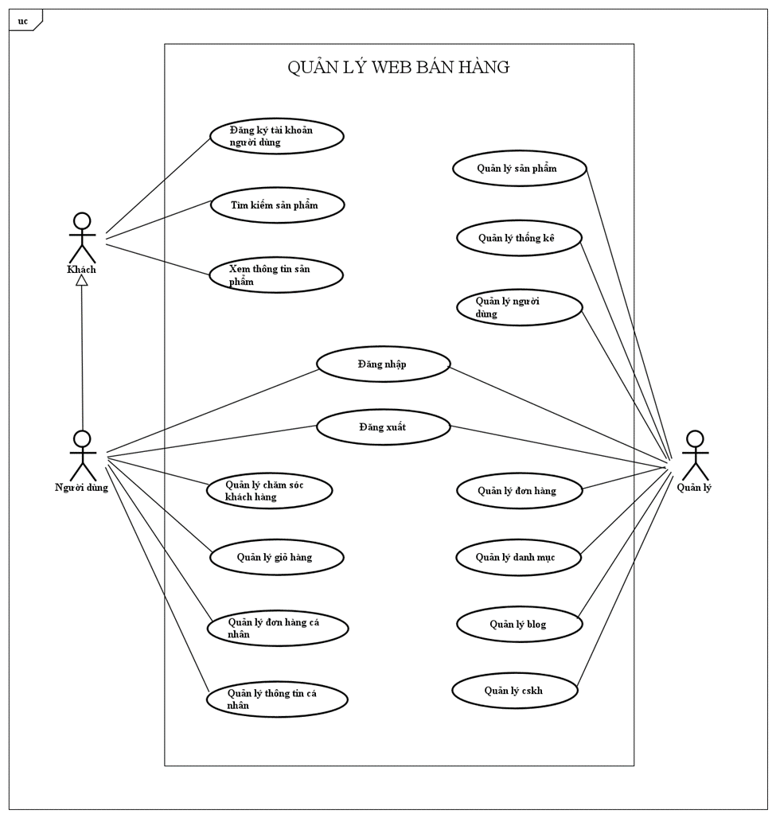
Diagram Description: The UML Use Case Diagram visualizes the functional scope of ShopSphere. It depicts the Web Customer interacting with core features like "Search Catalog" and "Make Purchase," while the Administrator handles "Product Management."
A critical part of the model is the "Make Purchase" use case, which includes the "Secure Payment" use case (mandatory interaction with the Payment Gateway) and is extended by the "Apply Coupon" use case (optional behavior). This structure clearly defines the system boundaries and external dependencies.

2. Architectural Analysis of ASRs
This section analyzes how the identified ASRs will map to the Layered Architecture in the upcoming design phase.
- ASR-1 (Security) → Business Logic Layer: Security policies and validation logic must be enforced within the Business Logic Layer. This ensures that unauthorized access is blocked regardless of whether the request comes from the Web UI or another source, protecting the core services effectively.
ASR-2 (Performance) → Persistence & Business Layers: To meet performance goals, the architecture must allow the Business Logic layer to implement caching or efficient data retrieval strategies from the Persistence layer without affecting the Presentation layer. This separation allows the catalog read operations to be optimized indepen

